GROW YOUR OWN ….. FLOWER THAT IS! Supply list
*******PLEASE COME TO CLASS WITH STEP 1 AND 2 COMPLETED********

10” x 15” cotton fabric – Backing
10” x 15” cotton fabric – Background
10” x 15” thin cotton batting

1)Start by creating a small 10” x 15” quilt for the background.
Cotton fabrics (does not have to be batik for this part)

2)Sandwich the Backing, Batting and Background, Baste these layers. Quilt these together using a random stitching pattern, a grid pattern or a wavy line grid pattern (see. Below).
This creates a sturdy “canvas” on which to apply your applique.

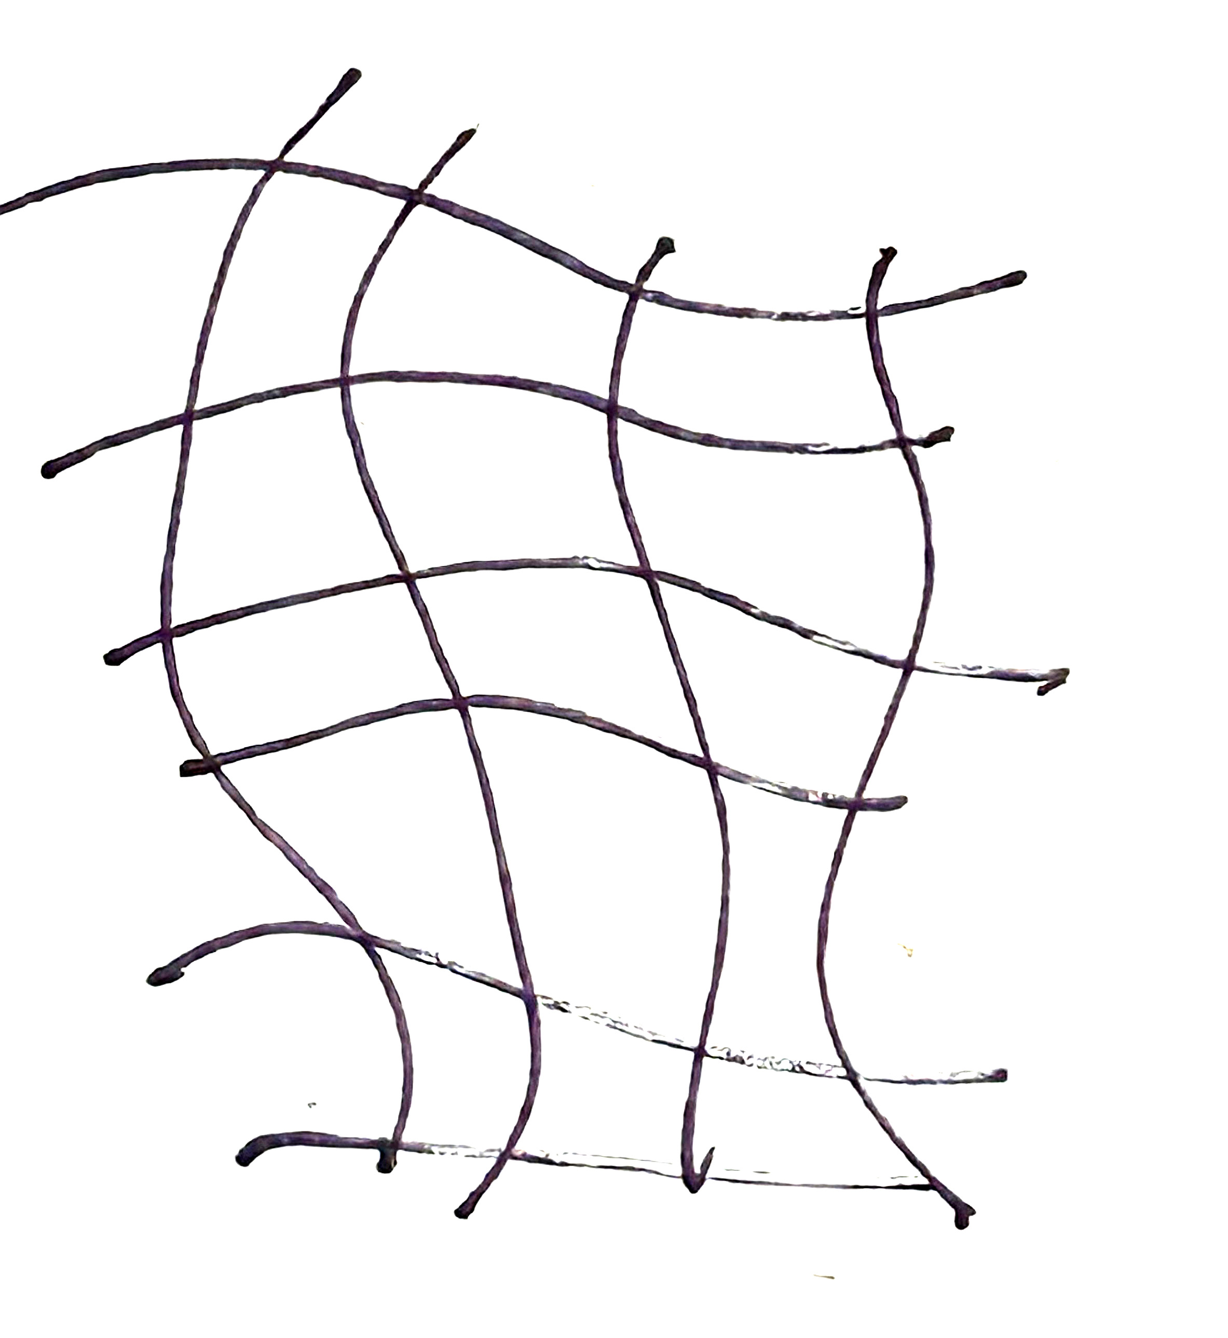

Batiks needed for Flower, Stem and Leaves
Patterns are for a Poppy, Iris or Lily
Pick colors appropriate for one or the other (Or make a funky unusually colored flower).
Some fabrics with a design and or different color fields are a good idea. Lots of options that way.

Bring a minimum of:
3 - 8” square pieces of green in a variety of values (light medium and dark)
6 – 6” squares of the color you want for your flower. (again – a variety of light, medium and darks)

Threads should match the values and colors of the fabrics to the best of your ability. I use variegated threads almost every time!

Bobbins should be in a value range as well. I use light, medium and dark grays and always carry a white bobbin for those real pale colors.
Sharon Bottle Souva
Fabric Handworks
smsouva@yahoo.com

